Project Design Phase-II
Data Flow Diagram & User Stories

Date | 2 October 2026
Team ID | SWTID-2026-6670
Project Name | Implement Client Script & UI Policy (Incident)
Maximum Marks | 4 Marks

Data Flow Diagrams:
A Data Flow Diagram (DFD) is a traditional visual representation of the information flows within a system. A neat and clear DFD can depict the right amount of the system requirement graphically. It shows how data enters and leaves the system, what changes the information, and where data is stored.
Example: Incident data entry and validation (Level 0)
1. The agent opens an Incident (form or list) and enters Impact and other field values.
2. UI Policy rules (stored as configuration) set Assignment group as mandatory and Urgency as read-only when Impact is High.
3. Client Scripts auto-set Urgency, block save if Assigned To is empty, and block State edits in the list.
4. A validated record is saved to the Incident table.
Level 0 Data Flow Diagram
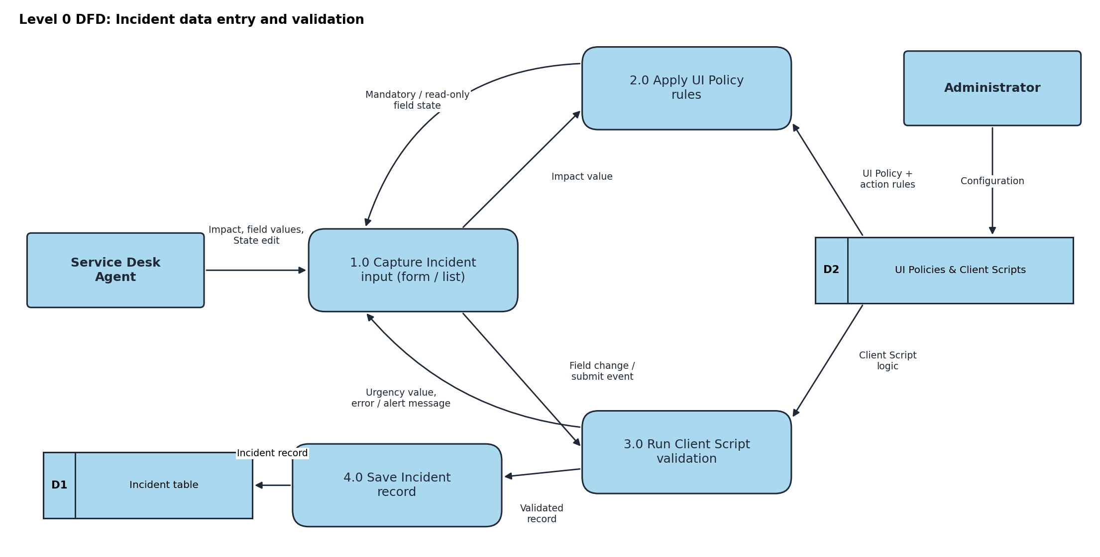
User Stories
Use the below template to list all the user stories for the product.
User Type | Functional Requirement (Epic) | User Story Number | User Story / Task | Acceptance criteria | Priority | Release
Service Desk Agent | High Impact Control (UI Policy) | USN-1 | As a service desk agent, I must enter an Assignment group when Impact is High so the incident is routed. | Assignment group shows as mandatory and the form will not save without it | High | Sprint-1
 |  | USN-2 | As a service desk agent, I want mandatory and read-only rules removed when Impact is lowered, so I can keep working normally. | Changing Impact from High to Medium makes Assignment group optional and Urgency editable | Medium | Sprint-1
 | Urgency Control | USN-3 | As a service desk agent, I want Urgency locked when Impact is High so it cannot be set inconsistently. | Urgency is read-only whenever Impact = 1 - High | High | Sprint-1
 | Auto-set Urgency (onChange) | USN-4 | As a service desk agent, I want Urgency set to High automatically when I pick High Impact, so I save time. | Urgency = 1 - High and an info message appears | High | Sprint-1
 | Save Validation (onSubmit) | USN-5 | As a service desk agent, I want to be warned if Assigned To is empty on a High impact incident. | Save is blocked and an error appears on Assigned To; save works once filled | High | Sprint-1
 | List Edit Control (onCellEdit) | USN-6 | As a service desk agent, I want to be told to open the form when I try to edit State in the list. | Alert is shown and the State value stays unchanged | Medium | Sprint-2
Incident Manager / Resolver | Incident Ownership | USN-7 | As an incident manager, I want every High impact incident to have an owner, so none are left unassigned. | No saved High impact incident has an empty Assigned To | High | Sprint-1
 | Data Quality | USN-8 | As an incident manager, I want State changes made only through the form so updates are controlled. | State can be updated on the form but not from the list | Medium | Sprint-2
Administrator | Configuration | USN-9 | As an administrator, I want to configure UI Policies and Client Scripts on the Incident table. | Policy and scripts are active and enforced on the Incident form | High | Sprint-1
 | Testing | USN-10 | As an administrator, I want to test all scenarios so I know each rule works. | Mandatory, successful save, reverse, list edit and form update tests all pass | Medium | Sprint-2

